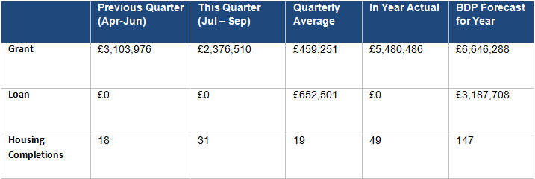
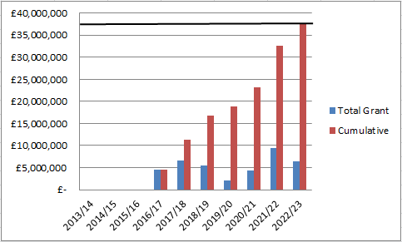
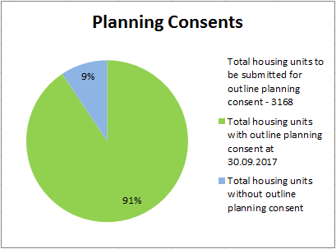
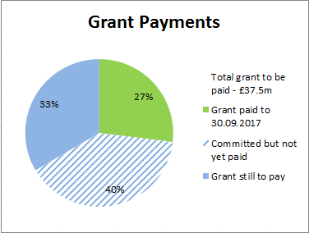
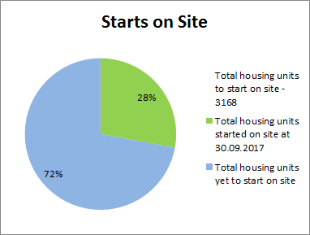
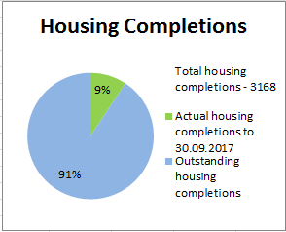
Residential development is underway on five outlets. There has been a slight increase in housing completions to reflect the increased development activity on Cottam Hall, Eastway, Whittingham and Croston Road South.
No additional Starts on Site during this reporting period.

Starts on Site are counted for the entire site on commencement of first unit.
£2,376,510 of grant paid in this reporting period. The grant was high this quarter due to a committed payment of almost £2.228m being made by Story and paid back out to LCC. The remainder of the grant paid this quarter relates to Cottam Ph1’s plot sales.
No additional planning permission for residential development secured by HCA in this reporting period.

Only Pickerings Farm is yet to achieve planning, however an amended planning consent for remaining Whittingham phases is required.

1.0 Report Overview

  - This report provides an update on the progress made by the HCA on the delivery of the City Deal housing sites from 01.07.17 to 30.09.17. It focuses on the key delivery milestones, finances invested, outputs and draws out key risks and emerging issues.

  - Recommendation

  - The Stewardship Board and Executive are recommended to note the content of the report and the progress made

- HCA Site Highlights (01.07.17 to 30.09.17)

  - Between the period 01.07.17 and 30.09.17, progress has been made on a number of HCA sites. Key highlights and future milestones can be found in the table below:

Site | Project | Status | Completions/  total units | Completions (Jul-Sep) | Finance  (Jul-Sep) | Summary | Milestones for next quarter (Oct-Dec)
1 | Cottam Hall Phase 1 (Site K) | Barratts on site | 74/104 (71%) | 6 | £148,510 grant paid to LCC in this reporting period | The grant consisted of payments from 5 plot sales.  Since the end of the reporting period a further £29,702 has been paid in grant to LCC. | Further grant payments are anticipated however the amounts are dependent on plot sales.
 | Cottam Hall Phase 2 | Story Homes on site. | 31/283 (11%) | 3 | N/A | 2 completions since the end of the reporting period. | N/A – ongoing build out
 | Cottam Hall Phase 3 | Deal done with Morris Homes - not yet on site. RM application submitted. | 0/119 (0%) | N/A | N/A | RM application was submitted in March 2017. The application did not go to September’s planning committee as anticipated last quarter. HCA have continued to work with Morris and this should now go to December’s planning committee. | RM application to go to January planning committee. The deal is anticipated to go unconditional in March once JR period has expired. This will trigger the loan payment (£3.9m)
2 | Cottam Brickworks | Planning permission in place | 0/206 (0%) | N/A | N/A | Site in 3rd party ownership. Access land agreement has lapsed. | No progress envisaged by land owner in forthcoming quarter.
3 | Land at Eastway (resi) | Story Homes on site. | 17/300 (6%) | 9 | £1.17m loan repaid,  £2.28m grant payment made to LCC | There have been a further 4 completions since the end of the reporting period.  LCC re-paid their loan of £1.17m in August. A grant payment of £2.28m was made to LCC in August following receipt of a contractual payment from Story Homes. | N/A – ongoing build out
 | Land at Eastway (commercial) | Conditional contracts exchanged with HBS Healthcare Ltd – not yet on site. | N/A (commercial) | N/A | N/A | The site was sold to HBS Healthcare Ltd in May on a conditional basis – the condition is that Story Homes construct the access to the site. They now have planning consent for the access road and changes to the guild wheel. HBS has submitted a planning application for the site. | More information on planning committee date anticipated.
4 | Whittingham | Taylor Wimpey on site (phase 1 only) | Ph 1 - 61/150 (41%) | 5 | N/A | Consultant procurement to resolve planning and design issues commenced.  A further 2 completions on Ph 1 since the end of the reporting period.  A number of properties on Ph1 appear complete, but are not being recorded as having achieved PC by TW who are unable to sell houses freehold due to a legal technicality. | Tenders for consultant appointment to be received in November for revised planning application. Expected to appoint early December
5 | Preston East EA | Site not yet marketed | N/A (commercial) | N/A | N/A | Feasibility work being undertaken by consultants is still ongoing. | Soft market testing report being undertaken by JLL to be received by HCA.
 | Preston East – Sector D | Deal completed with Inchcape Estates – now on site | N/A | N/A | N/A | Inchscape Estates have secured planning permission and are now on site | N/A
6 | Pickerings Farm | Site not yet marketed | 0/297 (0%) | N/A | N/A | Negotiations with Taylor Wimpey re collaboration agreement progressing well. Formal HCA approval expected in Jan along with consultant appointments. | Consultant tender responses to be received. Interviews to take place late November/early December
7 | Altcar Lane | Site currently on the market | 0/200 (0%) | N/A | N/A | Following marketing, 11 expressions of interest received. 6 responses to the sifting brief and 4 of these were shortlisted. ITT issued to the 4 shortlisted parties.  Further progress since the end of the reporting period - 2 tenders received on 1 November from Galliford Try and Lovell. These are currently being assessed.  Meeting took place with HCA and the planers at South Ribble Borough Council in November and planners considered both schemes to be good. | HCA will hopefully have a preferred bidder in place by late Dec/ early Jan.
8 | Croston Road North | Site not yet marketed | 0/400 (0%) | N/A | N/A | Phase 1 now agreed with South Ribble. HCA due to start marketing this phase in June 2018. Progress has been made on the acquisition of land currently outside of HCA ownership. | N/A
9 | Croston Road South | Miller on site. | 40/175 (23%) | 9 | N/A | Millers on site and building out.  There have been 3 further completions since the end of the reporting period. | N/A – ongoing build
10 | Brindle Road | Complete | 46/46 (100%) | N/A | N/A | All units completed. | N/A
11 | Walton Park Link | Morris on site | 0/350 (0%) | N/A | N/A | Deal between Morris Homes and National Grid has now gone unconditional. Morris commenced on site in September. | N/A – ongoing build

4.0 Risks

4.1 Ongoing delays associated with Pickerings Farm and Whittingham Hospital risk the ongoing success of housing delivery across HCA land. Measures are being put in place to address the delays and expedite progress where possible.

4.2 The collaboration agreement with TW at Pickerings Farm should be exchanged in early 2018. This will then enable the masterplanning work to progress.

4.3 HCA are at an advanced stage with the consultant procurement at Whittingham Hospital to progress the revised planning application.

4.2 Viability remains a concern at Whittingham Hospital due to the level of abnormal costs associated with a new spine road, foul sewer connection and the provision of a new sports facility. Partners will be engaged in these discussions at the earliest opportunity.

5.0 Summary

5.1 Overall positive progress is being made across the portfolio. The 31 completions last quarter were significantly higher than the quarterly average. Other particular successes include:

- Walton Park Link Road – The deal between Morris Homes and National Grid has now gone unconditional. Morris Homes started on site in September
- Altcar Lane – A good response from the marketing exercise with 11 EOIs being received, 6 responses to the sifting briefs and 4 shortlisted parties.
- Preston Sector D – Inchscape secured planning permission and started on site

Housing activity should increase over the course of the coming 12 months with a start on site expected at Altcar Lane and marketing underway at Croston Road North Phase1 and Cottam Hall Phase 4.

5.2 HCA are on track to pay the £37.5m grant by 2022/23.
